# Time Complexity of Algorithms

Asymptotic analysis of an algorithm refers to defining the mathematical boundation/framing of its run-time performance. Using asymptotic analysis, we can very well conclude the best case, average case, and worst case scenario of an algorithm.

Asymptotic analysis is input bound i.e., if there's no input to the algorithm, it is concluded to work in a constant time. Other than the "input" all other factors are considered constant.

Asymptotic analysis refers to computing the running time of any operation in mathematical units of computation. For example, the running time of one operation is computed as *f*(n) and may be for another operation it is computed as *g*(n2). This means the first operation running time will increase linearly with the increase in **n** and the running time of the second operation will increase exponentially when **n** increases. Similarly, the running time of both operations will be nearly the same if **n** is significantly small.

Usually, the time required by an algorithm falls under three types −

* **Best Case** − Minimum time required for program execution.
* **Average Case** − Average time required for program execution.
* **Worst Case** − Maximum time required for program execution.

Asymptotic Notations

Following are the commonly used asymptotic notations to calculate the running time complexity of an algorithm.

* Ο Notation
* Ω Notation
* θ Notation

Big Oh Notation, Ο

The notation Ο(n) is the formal way to express the upper bound of an algorithm's running time. It measures the worst case time complexity or the longest amount of time an algorithm can possibly take to complete.

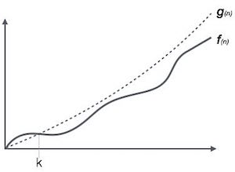

For example, for a function ***f*(n)**

Ο(*f*(n)) = { *g*(n) : there exists c > 0 and n0 such that *f*(n) ≤ c.*g*(n) for all n > n0. }

Omega Notation, Ω

The notation Ω(n) is the formal way to express the lower bound of an algorithm's running time. It measures the best case time complexity or the best amount of time an algorithm can possibly take to complete.

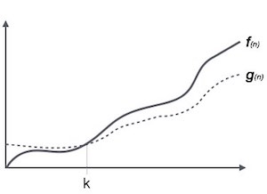

For example, for a function ***f*(n)**

Ω(*f*(n)) ≥ { *g*(n) : there exists c > 0 and n0 such that *g*(n) ≤ c.*f*(n) for all n > n0. }

Theta Notation, θ

The notation θ(n) is the formal way to express both the lower bound and the upper bound of an algorithm's running time. It is represented as follows −

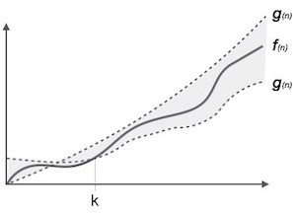

θ(*f*(n)) = { *g*(n) if and only if *g*(n) = Ο(*f*(n)) and *g*(n) = Ω(*f*(n)) for all n > n0. }

Common Asymptotic Notations

Following is a list of some common asymptotic notations −

|  |  |  |
| --- | --- | --- |
| constant | − | Ο(1) |
| logarithmic | − | Ο(log n) |
| linear | − | Ο(n) |
| n log n | − | Ο(n log n) |
| quadratic | − | Ο(n2) |
| cubic | − | Ο(n3) |
| polynomial | − | nΟ(1) |
| exponential | − | 2Ο(n) |

# Space Complexity of Algorithms

Whenever a solution to a problem is written some memory is required to complete. For any algorithm memory may be used for the following:

1. Variables (This include the constant values, temporary values)
2. Program Instruction
3. Execution

***Space complexity****is the amount of memory used by the algorithm (including the input values to the algorithm) to execute and produce the result.*

Sometime **Auxiliary Space** is confused with Space Complexity. But Auxiliary Space is the extra space or the temporary space used by the algorithm during it's execution.

**Space Complexity** = **Auxiliary Space + Input space**

## Memory Usage while Execution

While executing, algorithm uses memory space for three reasons:

1. **Instruction Space**

It's the amount of memory used to save the compiled version of instructions.

1. **Environmental Stack**

Sometimes an algorithm(function) may be called inside another algorithm(function). In such a situation, the current variables are pushed onto the system stack, where they wait for further execution and then the call to the inside algorithm(function) is made.

For example, If a function A() calls function B() inside it, then all th variables of the function A() will get stored on the system stack temporarily, while the function B() is called and executed inside the funciton A().

1. **Data Space**

Amount of space used by the variables and constants.

But while calculating the **Space Complexity** of any algorithm, we usually consider only **Data Space** and we neglect the **Instruction Space** and **Environmental Stack**.

## Calculating the Space Complexity

For calculating the space complexity, we need to know the value of memory used by different type of datatype variables, which generally varies for different operating systems, but the method for calculating the space complexity remains the same.

|  |  |
| --- | --- |
| **Type** | **Size** |
| bool, char, unsigned char, signed char, __int8 | 1 byte |
| __int16, short, unsigned short, wchar_t, __wchar_t | 2 bytes |
| float, __int32, int, unsigned int, long, unsigned long | 4 bytes |
| double, __int64, long double, long long | 8 bytes |

Now let's learn how to compute space complexity by taking a few examples:

{

int z = a + b + c;

return(z);

}

In the above expression, variables a, b, c and z are all integer types, hence they will take up 4 bytes each, so total memory requirement will be (4(4) + 4) = 20 bytes, this additional 4 bytes is for **return value**. And because this space requirement is fixed for the above example, hence it is called **Constant Space Complexity**.

Let's have another example, this time a bit complex one,

// n is the length of array a[]

int sum(int a[], int n)

{

int x = 0; // 4 bytes for x

for(int i = 0; i < n; i++) // 4 bytes for i

{

x = x + a[i];

}

return(x);

}

* In the above code, 4*n bytes of space is required for the array a[] elements.
* 4 bytes each for x, n, i and the return value.

Hence the total memory requirement will be (4n + 12), which is increasing linearly with the increase in the input value n, hence it is called as **Linear Space Complexity.**

Similarly, we can have quadratic and other complex space complexity as well, as the complexity of an algorithm increases.

But we should always focus on writing algorithm code in such a way that we keep the space complexity **minimum**.

In divide and conquer approach, the problem in hand, is divided into smaller sub-problems and then each problem is solved independently. When we keep on dividing the subproblems into even smaller sub-problems, we may eventually reach a stage where no more division is possible. Those "atomic" smallest possible sub-problem (fractions) are solved. The solution of all sub-problems is finally merged in order to obtain the solution of an original problem.

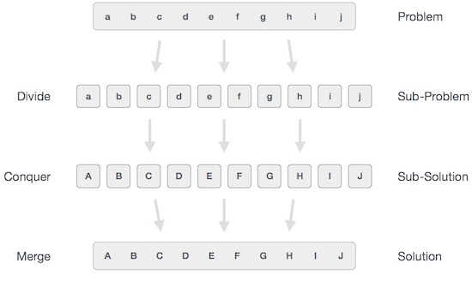

Broadly, we can understand **divide-and-conquer** approach in a three-step process.

Divide/Break

This step involves breaking the problem into smaller sub-problems. Sub-problems should represent a part of the original problem. This step generally takes a recursive approach to divide the problem until no sub-problem is further divisible. At this stage, sub-problems become atomic in nature but still represent some part of the actual problem.

Conquer/Solve

This step receives a lot of smaller sub-problems to be solved. Generally, at this level, the problems are considered 'solved' on their own.

Merge/Combine

When the smaller sub-problems are solved, this stage recursively combines them until they formulate a solution of the original problem. This algorithmic approach works recursively and conquer & merge steps works so close that they appear as one.

Examples

The following computer algorithms are based on **divide-and-conquer** programming approach −

* Merge Sort
* Quick Sort
* Binary Search
* Strassen's Matrix Multiplication
* Closest pair (points)

There are various ways available to solve any computer problem, but the mentioned are a good example of divide and conquer approach.

# Data Structure - Recursion Basics

Some computer programming languages allow a module or function to call itself. This technique is known as recursion. In recursion, a function **α** either calls itself directly or calls a function **β** that in turn calls the original function **α**. The function **α** is called recursive function.

**Example** − a function calling itself.

int function(int value) {

if(value < 1)

return;

function(value - 1);

printf("%d ",value);

}

**Example** − a function that calls another function which in turn calls it again.

int function1(int value1) {

if(value1 < 1)

return;

function2(value1 - 1);

printf("%d ",value1);

}

int function2(int value2) {

function1(value2);

}

## Properties

A recursive function can go infinite like a loop. To avoid infinite running of recursive function, there are two properties that a recursive function must have −

* **Base criteria** − There must be at least one base criteria or condition, such that, when this condition is met the function stops calling itself recursively.
* **Progressive approach** − The recursive calls should progress in such a way that each time a recursive call is made it comes closer to the base criteria.

## Implementation

Many programming languages implement recursion by means of **stacks**. Generally, whenever a function (**caller**) calls another function (**callee**) or itself as callee, the caller function transfers execution control to the callee. This transfer process may also involve some data to be passed from the caller to the callee.

This implies, the caller function has to suspend its execution temporarily and resume later when the execution control returns from the callee function. Here, the caller function needs to start exactly from the point of execution where it puts itself on hold. It also needs the exact same data values it was working on. For this purpose, an activation record (or stack frame) is created for the caller function.

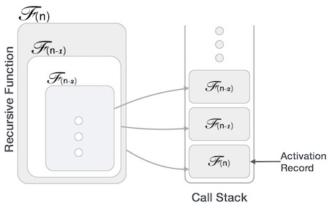

This activation record keeps the information about local variables, formal parameters, return address and all information passed to the caller function.

## Analysis of Recursion

One may argue why to use recursion, as the same task can be done with iteration. The first reason is, recursion makes a program more readable and because of latest enhanced CPU systems, recursion is more efficient than iterations.

## Time Complexity

In case of iterations, we take number of iterations to count the time complexity. Likewise, in case of recursion, assuming everything is constant, we try to figure out the number of times a recursive call is being made. A call made to a function is Ο(1), hence the (n) number of times a recursive call is made makes the recursive function Ο(n).

## Space Complexity

Space complexity is counted as what amount of extra space is required for a module to execute. In case of iterations, the compiler hardly requires any extra space. The compiler keeps updating the values of variables used in the iterations. But in case of recursion, the system needs to store activation record each time a recursive call is made. Hence, it is considered that space complexity of recursive function may go higher than that of a function with iteration.

Tower of Hanoi, is a mathematical puzzle which consists of three towers (pegs) and more than one rings is as depicted −

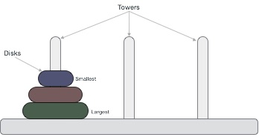

These rings are of different sizes and stacked upon in an ascending order, i.e. the smaller one sits over the larger one. There are other variations of the puzzle where the number of disks increase, but the tower count remains the same.

Rules

The mission is to move all the disks to some another tower without violating the sequence of arrangement. A few rules to be followed for Tower of Hanoi are −

* Only one disk can be moved among the towers at any given time.
* Only the "top" disk can be removed.
* No large disk can sit over a small disk.

Following is an animated representation of solving a Tower of Hanoi puzzle with three disks.



Tower of Hanoi puzzle with n disks can be solved in minimum **2n−1** steps. This presentation shows that a puzzle with 3 disks has taken **23 - 1 = 7** steps.

Algorithm

To write an algorithm for Tower of Hanoi, first we need to learn how to solve this problem with lesser amount of disks, say → 1 or 2. We mark three towers with name, **source**, **destination** and **aux** (only to help moving the disks). If we have only one disk, then it can easily be moved from source to destination peg.

If we have 2 disks −

* First, we move the smaller (top) disk to aux peg.
* Then, we move the larger (bottom) disk to destination peg.
* And finally, we move the smaller disk from aux to destination peg.



So now, we are in a position to design an algorithm for Tower of Hanoi with more than two disks. We divide the stack of disks in two parts. The largest disk (nth disk) is in one part and all other (n-1) disks are in the second part.

Our ultimate aim is to move disk **n** from source to destination and then put all other (n1) disks onto it. We can imagine to apply the same in a recursive way for all given set of disks.

The steps to follow are −

**Step 1** − Move n-1 disks from **source** to **aux**

**Step 2** − Move nth disk from **source** to **dest**

**Step 3** − Move n-1 disks from **aux** to **dest**

A recursive algorithm for Tower of Hanoi can be driven as follows −

START

Procedure Hanoi(disk, source, dest, aux)

IF disk == 1, THEN

move disk from source to dest

ELSE

Hanoi(disk - 1, source, aux, dest) // Step 1

move disk from source to dest // Step 2

Hanoi(disk - 1, aux, dest, source) // Step 3

END IF

END Procedure

STOP

Fibonacci series generates the subsequent number by adding two previous numbers. Fibonacci series starts from two numbers − **F0 & F1**. The initial values of F0 & F1 can be taken 0, 1 or 1, 1 respectively.

Fibonacci series satisfies the following conditions −

Fn = Fn-1 + Fn-2

Hence, a Fibonacci series can look like this −

F8 = 0 1 1 2 3 5 8 13

or, this −

F8 = 1 1 2 3 5 8 13 21

https://www.tutorialspoint.com/data_structures_algorithms/fibonacci_series.htm